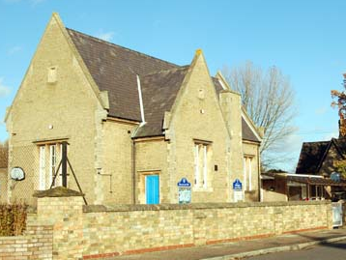
WILLINGTON LOWER SCHOOL
‘A great school in the heart of our village’
Newsletter

DECEMBER 2015
Issue 32

A Values School

OUR VALUE THIS MONTH:

PEACE



Stars of the Week in November were:

Reception: Jake, Olivia, Lacey, Johnny
Year 1: Sam, Matteo, Colin, Ava
Year 2: Harry, Nate, Naima, Kai
Year 3: Kevin, Lelan, Lizzie, Sophia
Year 4: Eleanor, Freddie, Harrison, Mila
The Values Award from The Golden Box draw was won by Eden for helping Lizzie at Football Club when she had a lot of things to carry; to Tommy for tidying up the table on his own; to Austin for playing with Kevin and letting him be ‘it’ in the game and Zachary for helping his friends; Other good deeds were:- Harry helped Harvey when he fell over; Elliot was kind to Tommy and helped when his arm was hurting and Freddie helped Myles.

The Playground Awards for November go to James, Tamsin, Ava and Kyle
Achievements Outside School:
Matteo achieved a medal playing football for Kempston Colts.
Kevin achieved a Learn to Swim award.

Well done everyone!

Christmas Play – christmas with the aliens

The School Christmas Play this year, entitled Christmas with the Aliens, will be on Thursday 10th December at 2pm at the Methodist Chapel, with an evening performance on at 6.15pm. It lasts for about 30 minutes. The children have been working very hard remembering their lines and singing beautifully. We hope that you can join us!

Letters have been sent home, asking you to reserve your free tickets. There are two tickets per family per performance

Christmas Panto

The children will be enjoying a trip to the theatre in Wellingborough to see A Christmas Carol on Tuesday 15th December. We are very grateful to the Friends of Willington for buying the tickets for us. OH YES WE ARE!!

ICE SKATING AT FROSTS

On Thursday 16th December the children, and some willing parents, will be attempting to ice skate at Frosts real ice rink. Please remember that children will NOT NEED TO WEAR SCHOOL UNIFORM that day and MUST bring gloves to wear on the ice. Dress up warm but remember NO SCARVES.

Any volunteers to help us escort the children and/or skate on the ice will be greatly appreciated, as it takes a long time to get all those skates on!! Please let us know if you can help.

END OF TERM CAROL SERVICE

On Friday 18th December everyone is invited to joins us at the Church at 9:30am for our end of term Carol Service. A lovely way to finish off the school term and be reminded of the meaning of Christmas.

bedford and district handicapped riders assocation

The children will be joining the fun at the Christmas party on Wednesday 9th December. We will be walking to the party in Balls Lane and will need to walk upon the grass verge, so please ensure children bring appropriate footwear, such as boots or sturdy shoes.

NEWS FROM OAKS

General Oaks News

We are enjoying our journey into space as we continue with our topic. The children have produced some fantastic pastel pictures of planets and stars and refined their skills in doing this. They are currently in the process of writing stories set in space- we just hope the aliens they meet during these are as friendly as the ones in our play! The production is going well with the children displaying lots of talent and perseverance with line learning. We are looking forward to showing it to everyone.

Football Tournament

It seems a long time ago now but in early November a team made up of Oak and Acorn class members braved the wet weather to represent our school in a football tournament at Alban Academy. They played well finishing in fifth place and their exemplary behaviour made us very proud that they are Willington Pupils. Playing for us were: Eden, Evan, Archie, Fionan, Ollie, Freddie, Dylan and Lizzie.
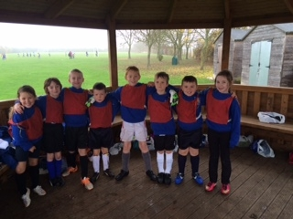

Egg Boxes

We still need egg boxes (six egg ones please) for our end of term DT project. Thanks to those who have already sent some in. If you have any please send them in by Thursday 10th December. Thank you!

Mrs Louise Buisson

CONGRATULATIONS!

Congratulations to Mrs Buisson on her news about expecting a new baby. We are delighted for her and her family!
SPRING TERM 2016 - AFTER SCHOOL CLUBS
Clubs will take place on the following days-
Monday – Football
Wednesday – Science
Thursday - Maths
Friday – Dodgeball

Please refer to the booking forms and contact information for details. Please note that the school is partly funding both the Maths and the Science Clubs in the hope that they will be well supported as these are fantastic opportunities for the children.

NEWS FROM ACORNS

Children in Need
We had a fun day when we all came to school dressed as Super Heroes to raise money. We also went on a walk around the village and popped into the Danish Camp for a drink and took our collecting bucket around to visitors. Thank you to Danish Camp for our drinks and biscuits and all those who supported our fund raising efforts.
Faith Tour
We went on a double decker bus to Bedford. Acorns sat on the top on the way home, which was very exciting! We had an interesting day learning about the three different places of worship and the religions they represent. Things they all had in common were their values of unity, friendship, peace and equality.
Art Days
We were very lucky to have visiting artists come into school, and together with Mrs Woodham, we had two fun days exploring different art topics. We studied the hangers and airships at Cardington and used different techniques and materials to create some great art work. We also started preparing for Christmas and made some Christmas cards.
Space
Our topic work has taken us up up and way into Space. We are really enjoying this topic. In English we have been researching and recounting the life and achievements of Neil Armstrong, as well as planning and writing our own alien fantasy stories. In studying the solar system and its planets we have worked collaboratively to make a modroc model. We painted this and it’s now hanging in the class room. The children are very proud of our model of the planets.
We are all now getting very excited about Christmas and practising for our Christmas play which we hope you will all be able to come and see us perform.

Mrs Heidi Smith

CHARITY NEWS!

Friday 13th November was Children in Need Day. Everyone came to school dressed as a hero or superhero for the day. A total of £149.87 was raised.

Thank you!
The School Council


POPPY APPEAL

The school sold poppies and other items for the Royal British Legion Poppy Appeal and managed to raise a total of £38.49!
CARE CLUB

As you will have noticed, our new Care Club has been delivered, utilities are being connected and the decorators are in. It is a lovely building and we are all looking forward to having the space back! We have been informed that it should be finished by the Christmas holiday, but there is no guarantee. We will continue to run Care Club from the main school building when we return to school in January, until we have a definite start date.

Thank you for your support during this term. It would seem that the children are continuing to enjoy it as much as they have always done.

In order to ensure the children’s safety please would you bring your children into Care Club in the mornings and ensure that they are handed over to a member of Care Club staff.

Starting time for Care Club in the morning remains at 7.50 am.

The contact number during Care Club hours only is 07719 074675.

NEWS FROM SQUIRRELS

November has been another busy month in Squirrels.
After the recent gales we have been spending time in the garden sweeping leaves but they still keep coming down! The children also made their own kites – it was great fun flying them in the windy weather! We also tried to build dens to shelter from the wind.
We have now made our Christmas cakes; the classroom smelt lovely for a couple of days. Everyone had a stir and made a wish.
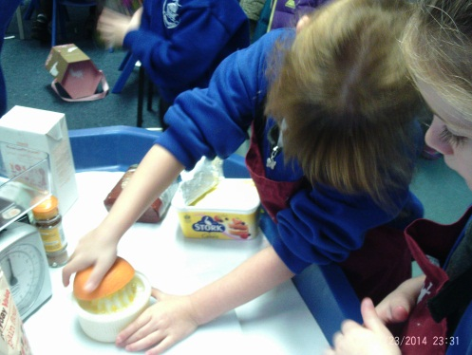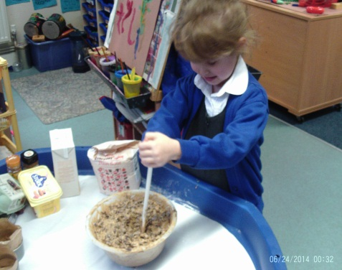
We are now joining the rest of the school rehearsing our part in the Christmas play.
We would like to say a big thank you to Bethany’s nanny who has knitted this wonderful nativity scene for us, the children are really enjoying telling the Christmas story to each other.
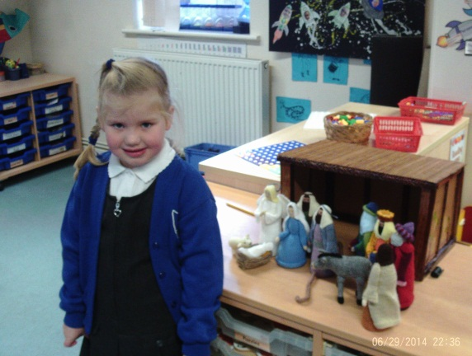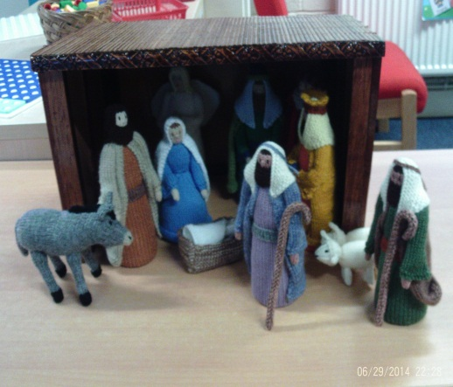
Mrs Julia Staley

THE FRIENDS
All the staff and children at the school would like to say a very big THANK YOU to the Friends for all their hard work. They generously give up their time to organise events for everyone to enjoy and raise funds for the children. We are grateful for everything you do and appreciate your support.

VILLAGE NATIVITY PAGEANT

The Village Churches together welcome you to join them at 7pm at the Village Playing Field on Friday 11th December.

CONTACT DETAILS REMINDER

Our email address has changed to office@willingtonlowerschool.org

Our phone number remains as 01234 838280.

SNOW DAY PROCEDURES
Please be advised that in the event of snow we will try to maintain normal opening hours. However, please be aware that if some of teaching staff cannot make it into school that day the school will be run as activity sessions.

For information and updates on school closures please visit the Bedford Borough Council website and look for the school closure page. The link for the school closures page is www.bedford.gov.uk/schoolclosures/

The school will endeavour to inform you by text as early as possible. With this in mind, please ensure the school has all up to date mobile / telephone numbers.

COFFEE MORNING

Just a reminder that the Coffee Morning that was due to take place on the 27th November has been postponed to the New Year. This will be a great opportunity for our Grand Opening of the new building.

We would like to wish you all a Merry Christmas and a Happy and Healthy New Year!

DIARY DATES:

DEC  8th  9th  10th  14th 15th  16th  18th  JAN 2016  4th  5th  11th  FEB  12th  22nd | Dress Rehearsal of Christmas Play 10am  Riding School Christmas Party  Performances of Christmas Play  2pm and 6:15pm  Christmas Maths Activity Afternoon  Pantomime at Wellingborough Theatre  Christmas Dinner  Ice Skating at Frosts  Church Service 9:30am  Last day of term  Staff training day  Children return to school  Swimming starts for Oak Class  Last day of half term  Children return to school



